Walkthrough - Wikipedia for Schools 2008/09 Collection
Background: 2008/9 Wikipedia DVD Selection is a free, hand-checked, non-commercial selection from Wikipedia, targeted around the UK National Curriculum and useful for much of the English speaking world. It has about 5500 articles and is about the size of a twenty volume encyclopaedia (34,000 images and 20 million words). Articles were chosen from a list ranked by importance and quality generated by project members. This list of articles was then manually sorted for relevance to children, and adult topics were removed. Website: http://schools-wikipedia.org
Kiwix is an open-source program designed to run offline Wikipedia archives stored in .ZIM files. With this, the Wikipedia for Schools package becomes compact, portable, and very easy to copy and spread to a large number of computers including older and slower ones. Website: http://www.kiwix.org/
Nature: Reference Encyclopedia; 2.77 GB Offline Software in one folder; no internet connection required to run
Works on: any Windows computer; other OS versions available on http://www.kiwix.org
Installation : NONE needed. You can just copy over the folder or even run it from the DVD/USB drive. Only step needed is to make a shortcut icon on the desktop so that users can find it easily.
Price: Free for non-commercial use and distribution; open source; we can copy it to any computer without any licensing issues.
Target audience: Can be used by all children, but is most useful for secondary classes onwards as a GK source / encyclopedia on computer. Great substitute for expensive paper encyclopedias. Also a good resource for school staff - they don't need to spend money at internet cafe's looking for information with this in hand.
How to get it: Best way is to copy it over from a friend; if not that then download it from here: http://download.kiwix.org/portable/kiwix-0.9-beta4+schools-wikipedia-full-20081023-rc5.zip . Note: The direct download link is known to be unreliable at times; use a download manager. See troubleshooting section at the end.
How to put it on a school computer:
1. Copy over the folder to the computer’s hard disk, or unzip it there in case you got it in zipped form.
2. Open the folder. This is what the files/folders inside will look like:
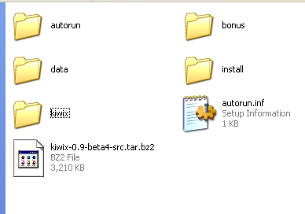 (ignore all the autorun, install etc files and folders – that is for when you burn this folder onto a DVD)
3. Go into the “kiwix” subfolder. In there you will find a file with a black kiwi bird icon called “kiwix” or “kiwix.exe” (most computers will hide the file extension). This is the main file that you need to run. To make this available to all the computer users, right-click it and choose “Send To > Desktop (create shortcut)”
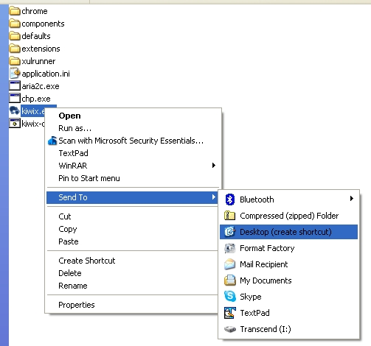
4. Now close all windows and get to the Desktop. You’ll find a new shortcut with the black kiwi icon. Rename it from “shortcut to kiwix” to a more apt “Wikipedia for Schools”.
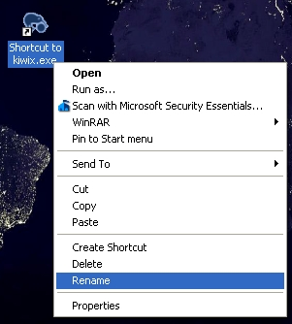
5. Now it’s ready. You can safely remove the USB drive / DVD. On double-clicking it, this window should open:
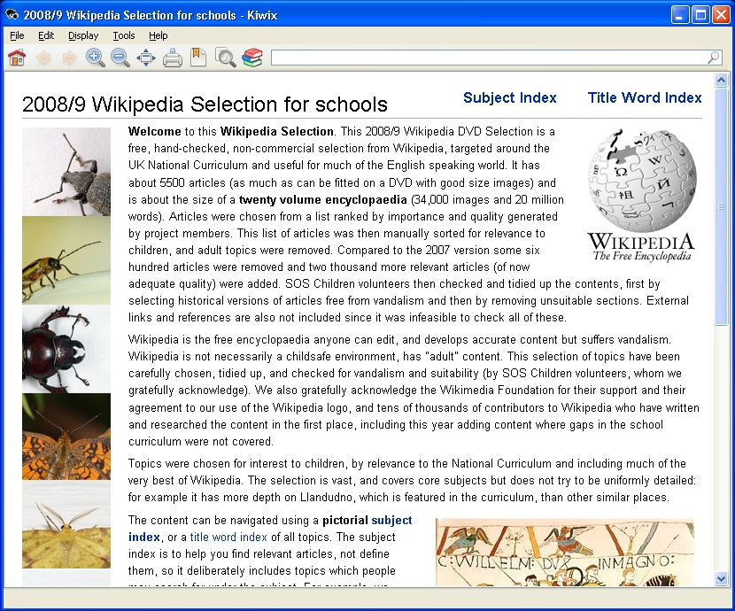
6. Test-run it by clicking in the white search bar at the top right and typing a topic.
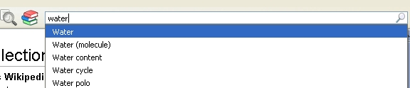
7. You can choose an article from the drop-down, or if no suggestions come then just press Enter and a search results page will come listing all the articles where your topic appears.
8. You can also just browse through different topics by clicking on “subject index” from the home page. (Click the Home icon on top left to go to the home page at any time)

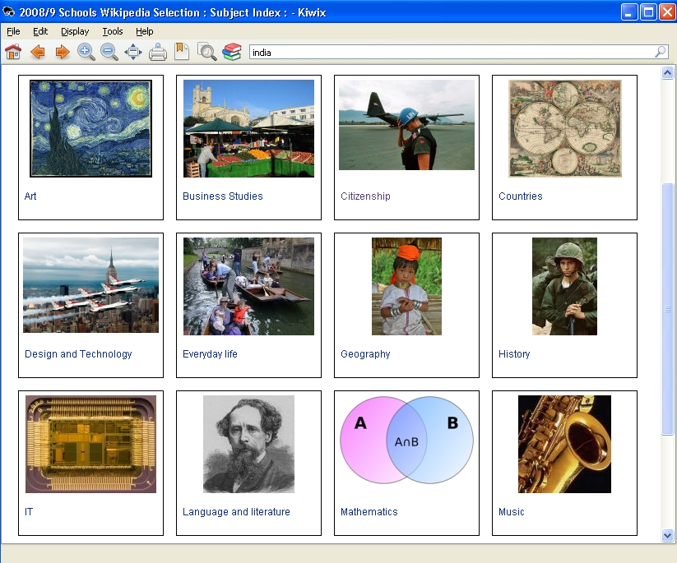
9. The encyclopedia replicates an internet browsing experience with hyperlinked words in each article leading to other articles or images, the same way one would browse on wikipedia online. The English is standard and has not been adapted for lower levels so it may be challenging for younger kids. But this collection has a lot of great images and the interface is quite easy with forward/back buttons, multiple tabs, zoom in/out. To get them started, you can show them the articles on DOG, CAT, EARTH, FLOWER etc.
Tip: For just exploring through pictures, tell the kids to type in “image” or “picture” or “photo” in the search bar and directly press Enter; you will get a list of all the images.
Troubleshooting:
In case after downloading this package from the internet (link) and extracting you get a message saying that the "schools-wikipedia-full-20081023-rc5.zim" was corrupted, then download this .zim file separately from http://download.kiwix.org/zim/0.9/schools-wikipedia-full-20081023-rc5.zim
or torrent http://download.kiwix.org/zim/0.9/schools-wikipedia-full-20081023-rc5.zim.torrent,
...and replace the corrupted ZIM file with the freshly downloaded one in the folder data>content in the Wikipedia for Schools folder.
The best option, of course, is to just take a copy from a contact who has it rather than downloading.

Regards
Nikhil Sheth
Teach for India Pune Fellow, 2011-13
Shantabai Ladkat School, Nanapeth, Pune
Mobile: +91-966-583-1250
Email: nikhil.sheth [at] teachforindia.org

